Assignment-3
Date: 04-11-2025
Name: Chittimalla Pujitha
Mtech 1st year
HTNO: 2503B05118

Task:1
Problem-01:
A bit stream 1101011011 is transmitted using the standard CRC method. The generator polynomial is x⁴+x+1. What is the actual bit string transmitted?

CODE:
#include <iostream>
#include <string>
#include <cmath>
#include <algorithm>
using namespace std;

// XOR between two binary strings
string findXor(string a, string b) {
string result = "";
for (int i = 1; i < b.length(); i++)
result += (a[i] == b[i]) ? '0' : '1';
return result;
}
// Modulo-2 division
string mod2div(string dividend, string divisor) {
int pick = divisor.length();
string tmp = dividend.substr(0, pick);

while (pick < dividend.length()) {
if (tmp[0] == '1')
tmp = findXor(divisor, tmp) + dividend[pick];
else
tmp = findXor(string(pick, '0'), tmp) + dividend[pick];
pick++;
}

if (tmp[0] == '1')
tmp = findXor(divisor, tmp);
else
tmp = findXor(string(pick, '0'), tmp);
return tmp;
}

// Encode data with CRC
string encodeData(string data, string key) {
int keyLen = key.length();
string appendedData = data + string(keyLen - 1, '0');
string remainder = mod2div(appendedData, key);
cout << "Remainder: " << remainder << endl;
return data + remainder;
}

int main() {
string data = "1101011011";
string key = "10011"; // x^4 + x + 1
cout << "=== TASK 1 ===" << endl;
cout << "Data: " << data << endl;
cout << "Key: " << key << endl;
string codeword = encodeData(data, key);
cout << "Transmitted Codeword: " << codeword << endl;
return 0;
}

OUTPUT:
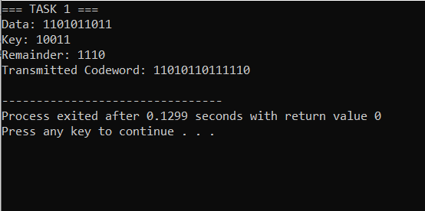

Task:2
Problem-02:
A bit stream 10011101 is transmitted using the standard CRC method. The generator polynomial is x³+1.

- What is the actual bit string transmitted?
- Suppose the third bit from the left is inverted during transmission. How will receiver detect this error?

CODE:
#include <iostream>
#include <string>
#include <cmath>
#include <algorithm>
using namespace std;

// XOR between two binary strings
string findXor(string a, string b) {
string result = "";
for (int i = 1; i < b.length(); i++)
result += (a[i] == b[i]) ? '0' : '1';
return result;
}

// Modulo-2 division
string mod2div(string dividend, string divisor) {
int pick = divisor.length();
string tmp = dividend.substr(0, pick);
while (pick < dividend.length()) {
if (tmp[0] == '1')
tmp = findXor(divisor, tmp) + dividend[pick];
else
tmp = findXor(string(pick, '0'), tmp) + dividend[pick];
pick++;
}

if (tmp[0] == '1')
tmp = findXor(divisor, tmp);
else
tmp = findXor(string(pick, '0'), tmp);
return tmp;
}

// Encode data with CRC
string encodeData(string data, string key) {
int keyLen = key.length();
string appendedData = data + string(keyLen - 1, '0');
string remainder = mod2div(appendedData, key);
cout << "Remainder: " << remainder << endl;
return data + remainder;
}

// Receiver check
bool receiverCheck(string codeword, string key) {
string remainder = mod2div(codeword, key);
return (remainder.find('1') == string::npos);
}

int main() {
string data = "10011101";
string key = "1001"; // x^3 + 1

cout << "=== TASK 2 ===" << endl;
cout << "Data: " << data << endl;
cout << "Key: " << key << endl;
string codeword = encodeData(data, key);
cout << "Transmitted Codeword: " << codeword << endl;
// Introduce error at 3rd bit
string received = codeword;
received[2] = (received[2] == '0') ? '1' : '0';
cout << "Received (error at bit 3): " << received << endl;
if (receiverCheck(received, key))
cout << "Receiver: No Error Detected" << endl;
else
cout << "Receiver: Error Detected" << endl;
return 0;
}

OUTPUT:
